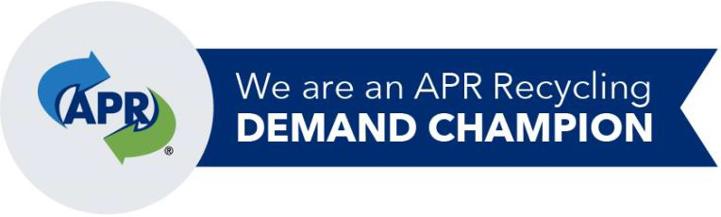
Reporting Form
2021

The NERC-APR Government Recycling Demand Champion Campaign enables government organizations committed to recycling and who recognize that “demand creates value and value drives recycling”, to proactively impact the domestic plastic recycling marketplace through their purchasing practices. This report verifies the positive impact your organization has had as a Champion. Please send completed reports to NERC.
Please complete a separate form for each type of product with plastic post-consumer recycled content that you purchased since becoming a Champion through June 30, 2021.
Today’s Date:

Organization Name:

Contact Person:

Email Address:

Documentation of your NERC-APR Government Recycling Demand Purchase
Government Demand Champion’s data will be consolidated to calculate the NERC-APR Government Demand Champion Campaign’s overall impact.

Date(s) of purchase: _
Product type & model number: _____________________________________ (carts, infrastructure pipe, etc.)
Product manufacturer: _________________________________________________________________

Number of items purchased: __________ __________ (quantity/size of carts, length of infrastructure pipe, etc.)
Percentage of PCR in the product, if known:

Please complete the following statement to certify the purchase of the above stated products.

I, __________________________________ (your name) certify that these products were purchased by

___________________________________ (organization name) between the month we became a

Government Recycling Demand Champions through June 2021.

Optional: Please attach invoices for the items purchased that contain PCR.

Photos speak a thousand words. Please include photos (action photos, - products in use, etc.) so that they can be used to illustrate what NERC-APR Government Recycling Demand Champions have accomplished.

